WEEK_1-DESIGN_PATTERNS – Superset ID: 7995206
Exercise 1: Implementing the Singleton Pattern
Solution Code:
- Logger.java
public class Logger {
private static Logger instance= new Logger();
private Logger(){
}
public static Logger getInstance(){
return instance;
}
}
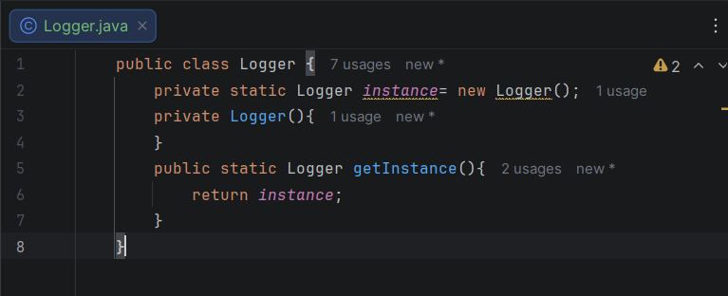
- Test.java
public class Test {
public static void main(String[] args) {
Logger logger1 = Logger.getInstance();
Logger logger2 = Logger.getInstance();
System.out.println(logger1 == logger2);
}
}
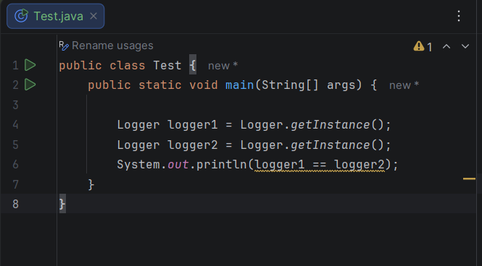

Output:
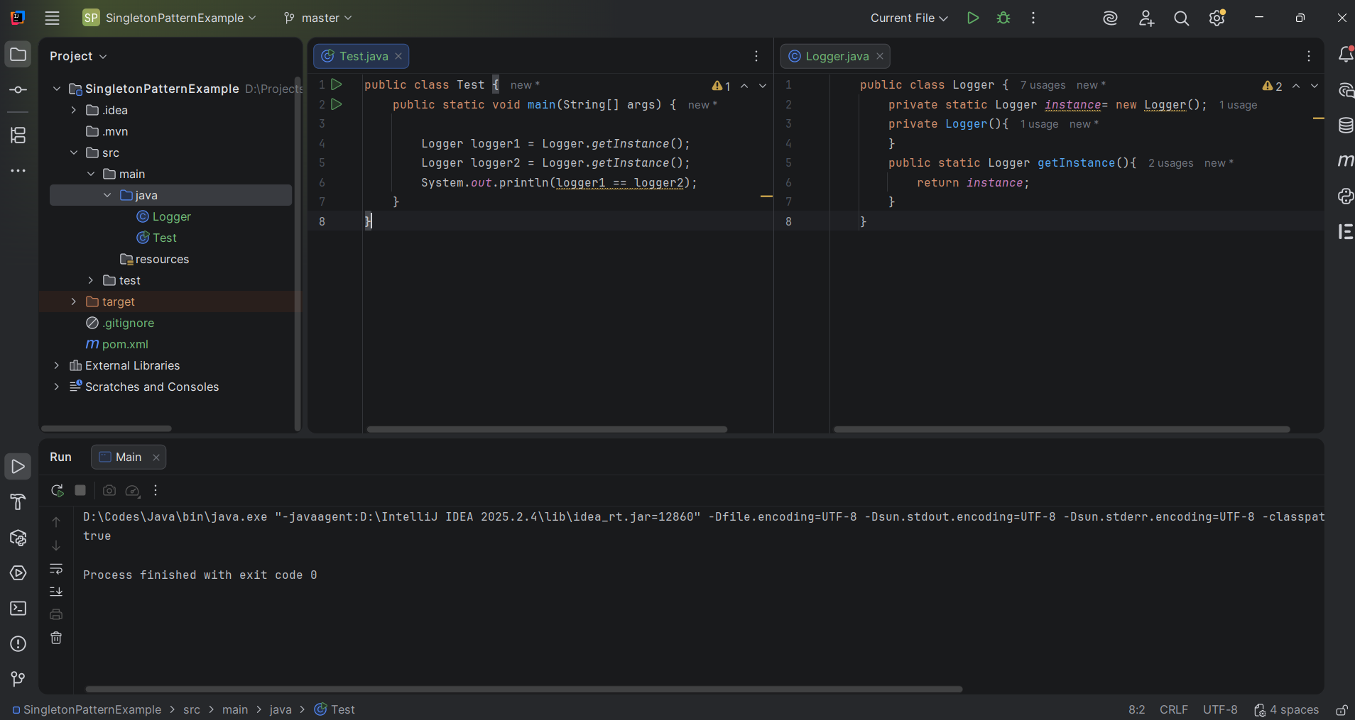

Exercise 2: Implementing the Factory Method Pattern
Solution Code:
Document.java
interface Document {
void open();
}
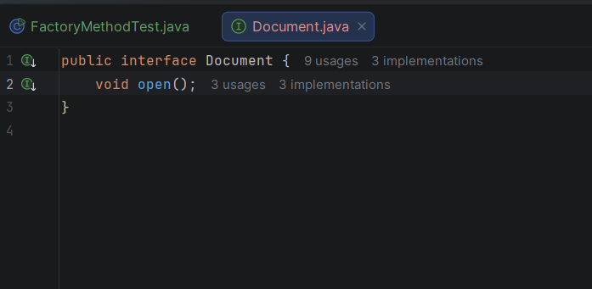
WordDocument.java
class WordDocument implements Document {
@Override
public void open() {
System.out.println("Opening Word Document");}}
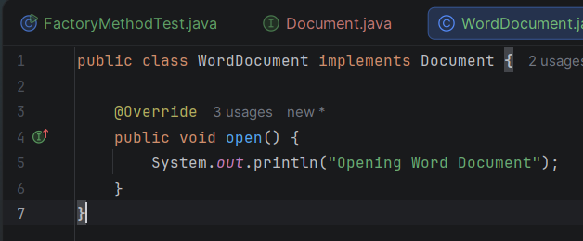

PdfDocument.java
class PdfDocument implements Document {
@Override
public void open() {
System.out.println("Opening PDF Document");}}
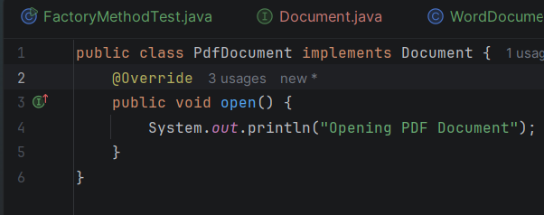
ExcelDocument.java
class ExcelDocument implements Document {
@Override
public void open() {
System.out.println("Opening Excel Document"); }}
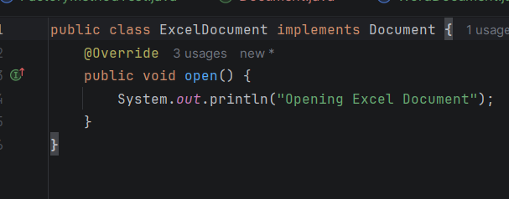
DocumentFactory.java
abstract class DocumentFactory {
public abstract Document createDocument();
}
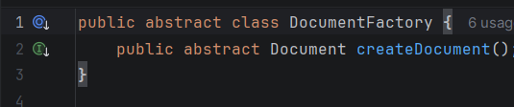
WordDocumentFactory.java
class WordDocumentFactory extends DocumentFactory {
@Override
public Document createDocument() {
return new WordDocument();}}
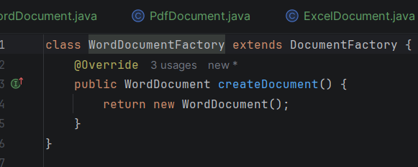
PdfDocumentFactory.java
class PdfDocumentFactory extends DocumentFactory {
@Override
public Document createDocument() {
return new PdfDocument();}}
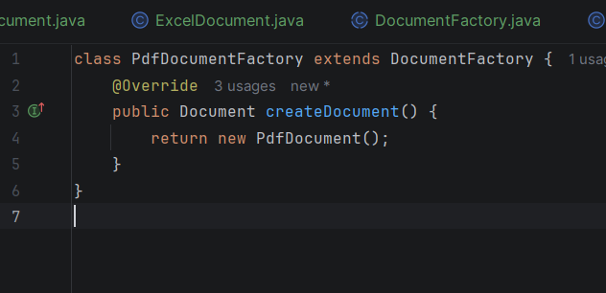

ExcelDocumentFactory.java
class ExcelDocumentFactory extends DocumentFactory {
@Override
public Document createDocument() {
return new ExcelDocument(); }}
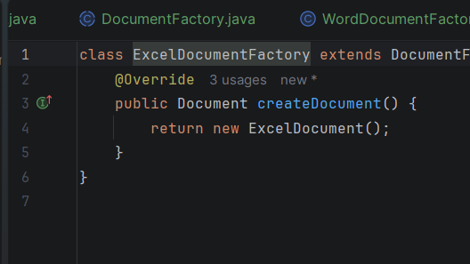
FactoryMethodTest.java
public class FactoryMethodTest {
public static void main(String[] args) {
DocumentFactory wordFactory = new WordDocumentFactory();
Document word = wordFactory.createDocument();
word.open();

DocumentFactory pdfFactory = new PdfDocumentFactory();
Document pdf = pdfFactory.createDocument();
pdf.open();

DocumentFactory excelFactory = new ExcelDocumentFactory();
Document excel = excelFactory.createDocument();
excel.open();
}
}
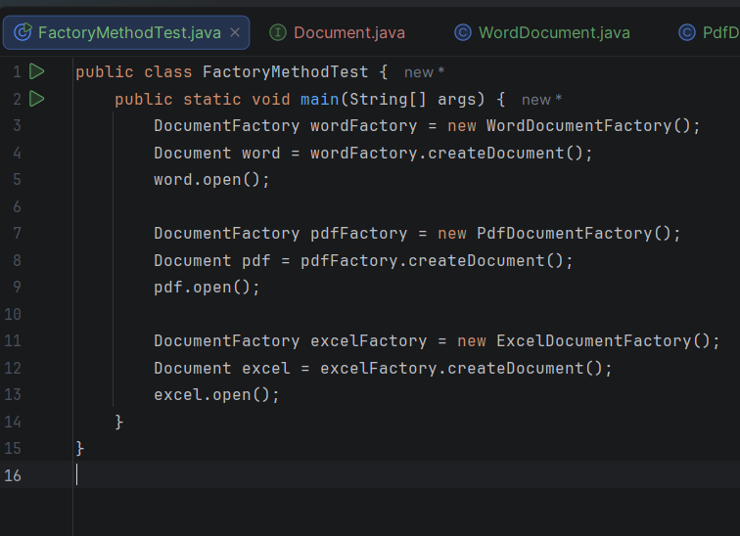

Output:
